Binary Search

Table of Contents
LEVEL 1: Amateur 2
1. Binary Search 2
2. Lower Bound, upper bound 2
3. First and last occurrence 2
4. Number of occurrences in sorted array 2
5. Find Kth Rotation 2
6. Search in Rotated Sorted Array 2
7. Sqrt(x) 2
8. Find Peak Element 2
LEVEL 2: Pro 3
1. Search in 2D matrix 3
2. Allocate Minimum number of pages 3
3. Koko Eating Bananas 3
4. Find the Smallest Divisor Given a Threshold 3
LEVEL 3: Legend 4
SOLUTIONS: 5
LEVEL 1: 5
LEVEL 2: 14

LEVEL 1: Amateur

Binary Search
Link: https://leetcode.com/problems/binary-search/description/

Lower Bound, upper bound
Link: https://www.geeksforgeeks.org/problems/implement-lower-bound/1
Link: https://www.geeksforgeeks.org/problems/implement-upper-bound/1

First and last occurrence
Link: https://leetcode.com/problems/find-first-and-last-position-of-element-in-sorted-array/

Number of occurrences in sorted array
Link: https://www.geeksforgeeks.org/problems/number-of-occurrence2259/1

Find Kth Rotation
Link: https://www.geeksforgeeks.org/problems/rotation4723/1

Search in Rotated Sorted Array
Link: https://leetcode.com/problems/search-in-rotated-sorted-array/

Search in Rotated Sorted Array II
Link: https://leetcode.com/problems/search-in-rotated-sorted-array-ii/

Sqrt(x)
Link: https://leetcode.com/problems/sqrtx/description/

Find Peak Element
Link: https://leetcode.com/problems/find-peak-element/description/

LEVEL 2: Pro

Search in 2D matrix
Link: https://leetcode.com/problems/search-a-2d-matrix/description/

Allocate Minimum number of pages
Link: https://www.geeksforgeeks.org/problems/allocate-minimum-number-of-pages0937/1

Koko Eating Bananas
Link: https://leetcode.com/problems/koko-eating-bananas/description/

Find the Smallest Divisor Given a Threshold
Link: https://leetcode.com/problems/find-the-smallest-divisor-given-a-threshold/description/

Level 2 — Applied (rotated arrays, 2D matrices, boundary-finding)
- Time Based Key-Value Store (LC 981) — binary search inside a hashmap-of-lists design, confirmed as a recurring FAANG variant
- Find the Smallest Divisor Given a Threshold (LC 1283) — binary search on answer
- Find Minimum in Rotated Sorted Array (153) LeetCode
- Find Minimum in Rotated Sorted Array II (154) LeetCode

- Search a 2D Matrix (74) LeetCode
- Search a 2D Matrix II (240) LeetCode
- Kth Smallest Element in a Sorted Matrix (378) LeetCode
- Find in Mountain Array (1095) LeetCode

- Capacity To Ship Packages Within D Days (1011) LeetCode
- Magnetic Force Between Two Balls (1552) LeetCode

- Single Element in a Sorted Array (540) LeetCode
- Missing Element in Sorted Array LeetCode Premium
- Find K Closest Elements (658) LeetCode

- Search in Bitonic Array GeeksforGeeks
- Number of Times Sorted Array is Rotated GeeksforGeeks
- Allocate Minimum Number of Pages GeeksforGeeks

LEVEL 3: Legend

Level 3 — Advanced / FAANG bar-raiser tier

- Minimize Max Distance to Gas Station (LC 774) — binary search on a real-valued answer space
- Median of a Row-Wise Sorted Matrix — GfG (no clean single LC equivalent), extends the matrix + binary search idea
- Nth Magical Number (LC 878) — binary search + math/LCM feasibility
- Woodcutter's Problem / Cutting Wood (Koko-style variant) — GfG (reinforces the same pattern from a different framing)

- Split Array Largest Sum (410) LeetCode
- Minimum Number of Days to Make m Bouquets (1482) LeetCode
- Divide Chocolate (1231) LeetCode
- Minimized Maximum of Products Distributed to Any Store (2064) LeetCode
- Maximum Value at a Given Index (1802) LeetCode

- Median of Two Sorted Arrays (4) LeetCode
- Kth Smallest Pair Distance (719) LeetCode
- Find K-th Smallest Pair Distance (719) LeetCode
- H-Index II (275) LeetCode

- Swim in Rising Water (778) LeetCode
- Path With Minimum Effort (1631) LeetCode
- Maximum Candies Allocated to K Children (2226) LeetCode

- Kth Smallest Element in a Sorted Matrix (378) LeetCode
- Search a 2D Matrix II (240) LeetCode

- Aggressive Cows GeeksforGeeks
- Painter's Partition Problem GeeksforGeeks
- Book Allocation Problem GeeksforGeeks

- Median of Two Sorted Arrays (4) LeetCode (Imp)
- Find in Mountain Array (1095) LeetCode
- Divide Chocolate (1231) LeetCode

SOLUTIONS:

LEVEL 1:

1. Binary Search

Iterative approach
class Solution:
def search(self, nums: List[int], target: int) -> int:
low, high = 0, len(nums)-1

while low<=high: #break condition
mid = (low+high)//2 #find mid every time
if nums[mid]==target:
return mid
if target>nums[mid]:
low = mid+1
else:
high=mid-1

return -1

Recursive approach
class Solution:
def search(self, nums: List[int], target: int) -> int:

def helper(low,high): #break condition
if low>high:
return -1
mid = (low+high)//2
if nums[mid]==target:
return mid
if target>nums[mid]:
return helper(mid+1,high)
return helper(low,mid-1)

return helper(0,len(nums)-1)

Not a issue in python, but in other languages ( L + R)//2 can give integer overflow issue. So, in place of this use
L + ( L – R)//2.

2. Lower Bound

Lower Bound
The lower bound refers to the index of the first element in a sorted list that is greater than or equal to a given target value.
If the target value is present in the list, the lower bound will be the index of its first occurrence.
If the target value is not present, the lower bound will be the index where the target value should be inserted to maintain the sorted order.

class Solution:
def lowerBound(self, arr, target):
ans = len(arr)
l,r = 0,len(arr)-1
while l<=r:
mid = (l+r)//2
if arr[mid]<target: #in upper bound, this just changes to <=
l = mid+1
else:
ans = mid
r = mid-1

return ans

#Can use python bisect library
import bisect
class Solution:
def lowerBound(self, arr, target):
#code here
return bisect.bisect_left(arr,target)

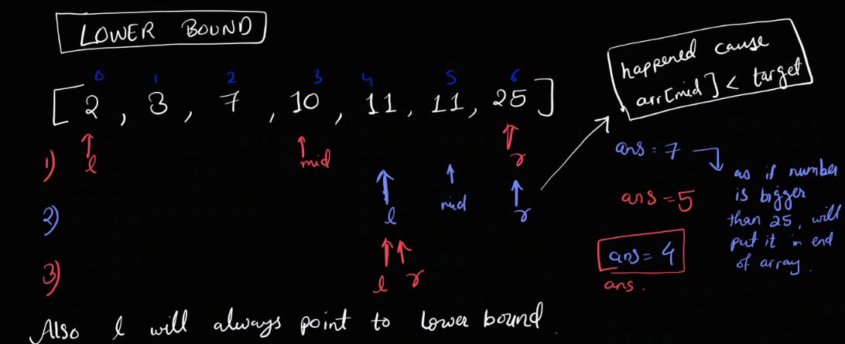

Every time arr[mid] >= target, mid is a candidate answer (since lower bound = first index with value ≥ target), so we record it in ans and search the left half for an even earlier one

Upper Bound
The upper bound refers to the index of the first element in a sorted list that is strictly greater than a given target value.
If the target value is present in list, the upper bound will be the index after the last occurrence of the target value.
If the target value is not present, the upper bound will be the same as the lower bound, indicating the insertion point.
class Solution:
def upperBound(self, arr, target):
ans = len(arr) #for both upper and lower bound, do this
l,r = 0,len(arr)-1
while l<=r:
mid = (l+r)//2
if arr[mid]<=target: #just changed to <= from < of lower bound
l = mid+1
else:
ans = mid
r = mid-1

return ans

#using bisect library
import bisect
class Solution:
def upperBound(self, arr, target):
return bisect.bisect_right(arr,target)

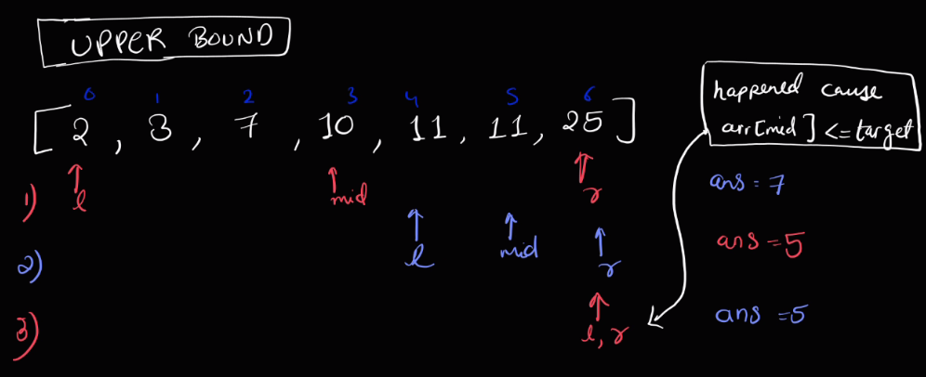

Upper bound = first index with value > target. So whenever arr[mid] <= target (mid is still ≤ target, not yet strictly greater), it can't be the answer, so discard left half and search right (l = mid+1); whenever arr[mid] > target, mid is a candidate answer, so record it in ans and keep searching left (r = mid-1) for an even earlier one. This converges ans to the first index strictly greater than target — just lower bound's logic with the comparison flipped from < to <=, since now "still not qualifying" includes equal-to-target values too.

3. First and Last occurrence of element
class Solution: #using basic binary search concept, and tracking target index
def leftOccurrence(self,nums,target):
low, high = 0, len(nums)-1
ans = -1

while low<=high:
mid = low + (high-low)//2 #another way to do (low +high) may go out of range so use this
if target==nums[mid]:
ans = mid
high = mid-1
elif target<nums[mid]:
high = mid-1
else:
low = mid+1
return ans

def rightOccurrence(self,nums,target):
low, high = 0, len(nums)-1
ans = -1
while low<=high:
mid = low + (high-low)//2
if target==nums[mid]:
ans = mid
low = mid+1
elif target<nums[mid]:
high = mid-1
else:
low = mid+1
return ans

def searchRange(self, nums: List[int], target: int) -> List[int]:
lower = self.leftOccurrence(nums,target)
upper = self.rightOccurrence(nums,target)
return [lower,upper]

Using upper bound and lower bound concept
import bisect
class Solution:
def searchRange(self, nums: List[int], target: int) -> List[int]:
low = bisect.bisect_left(nums,target) #lower bound give first occurance
high = bisect.bisect_right(nums,target) – 1
#if num is not present in array, can also have low > nums[len] if target>max(arr)
if(low==len(nums) or nums[low]!=target):
return [-1,-1]

return [low,high]

4. Number of occurrences in sorted array
Just find upper and lower bound of target. All number in this range [low, high) have value target.
In case target is not present, for that lower and upper bound will be same, hence will return 0

import bisect

class Solution:
def countFreq(self, arr, target):
# code here
return bisect.bisect_right(arr,target)-bisect.bisect_left(arr,target)

5. Find Kth Rotation
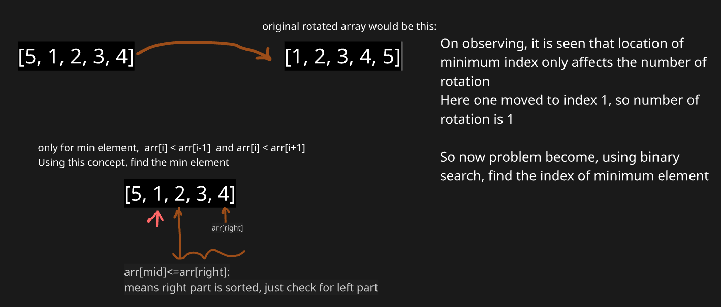

Below shows, how min will value will be present in left, by depicting 2 possible scenarios
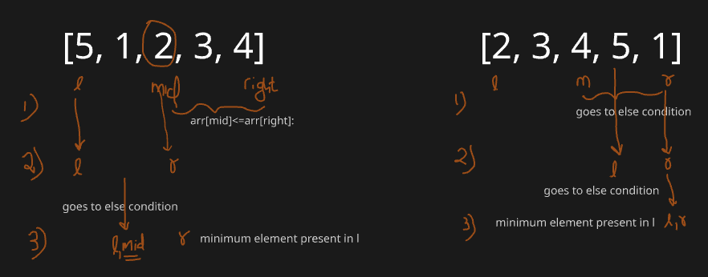

#reason why not mid-1
#for arr: 8,10,2,5,6: 2---6 is sorted array, 2 is min, if we do mid-1, we miss 2
class Solution:
def findKRotation(self, arr):
left,right = 0, len(arr)-1
while(left<right): #remember now not l<=r, it is l<r. As r not decreasing
mid = (left+right)//2
if arr[mid]<=arr[right]:
right = mid #remember it is not mid-1
else:
left = mid+1
return left

6. Search in Rotated Sorted Array
This code is solving search in a rotated sorted array using binary search.
- It keeps two pointers (left and right) and repeatedly finds the middle index (mid).
- If nums[mid] == target, return the index.
- Otherwise, it checks which half (left or right) is sorted.
  - If the left half is sorted, it checks if the target lies in that half → adjust right.
  - Else, the right half is sorted, and it checks if the target lies there → adjust left.
- If the element is not found, return -1.
Basically, it narrows down the search by always picking the sorted half where the target could exist.
class Solution:
def search(self, nums: List[int], target: int) -> int:
left, right = 0, len(nums) - 1

while left <= right:
mid = (left + right) // 2
if nums[mid] == target:
return mid
#left half is sorted
if nums[left] <= nums[mid]: #less than and equal for only one element array
if nums[left] <= target < nums[mid]:
right = mid - 1
else:
left = mid + 1
#right half is sorted
else:
if nums[mid] < target <= nums[right]:
left = mid + 1
else:
right = mid - 1
return -1

7. Search in Rotated Sorted Array 2
Core intuition: Even after rotation, at least one half of the array (left of mid, or right of mid) is always properly sorted. So at each step, first figure out which half is sorted, then check if target falls within that sorted half's range — if yes, search there; if no, it must be in the other (unsorted) half, so search there instead.

Why duplicates break the old approach: In the previous solution, nums[mid] >= nums[l] was used to decide "is the left half sorted?" But with duplicates, you can get a case like nums = [3,1,2,3,3,3,3] where nums[l] == nums[mid] == nums[r], yet the array is rotated. In that situation, you genuinely cannot tell which half is sorted just by comparing nums[l] and nums[mid] — both halves could look "equal" while one secretly contains the rotation point. This ambiguity is the key edge case duplicates introduce.
This can be fixed by extra condition:

if nums[l] == nums[mid] and nums[mid] == nums[r]:
l += 1
r -= 1

Code is:

class Solution:
def search(self, nums: List[int], target: int) -> bool:
l,r = 0,len(nums)-1
while l<=r:
mid = (l+r)//2
if nums[mid]==target:
return True
if nums[l]==nums[mid] and nums[mid]==nums[r]: #Just an extra condition
l+=1
r-=1
elif nums[l]<=nums[mid]:
if nums[l]<=target<nums[mid]:
r=mid-1
else:
l=mid+1
else:
if nums[mid]<target<=nums[r]:
l=mid+1
else:
r=mid-1
return False

8. Sqrt(x)
This is example of binary search on answer

Binary search on answer → Instead of searching in a sorted array, we search in the range of possible answers. Example: finding sqrt(x) by testing numbers 1…x.
When usable on unsorted data → If the search space is numeric/monotonic (e.g., “is it possible with k items?”), even if array isn’t sorted.
class Solution:
def mySqrt(self, x: int) -> int:
l,r = 1, x
ans =0 #will need to store ans
while l<=r:
mid = (l+r)//2
if mid*mid==x:
return mid

# if square of mid is less than x, it can be ans. But we need to find that largest mid
if mid*mid<x:
ans = mid
l = mid+1
else:
r = mid-1

return ans

Explanation:
- Search space: Binary search between l=1 and r=x, since the integer square root must fall in this range.
- Exact match: If mid*mid == x, return mid immediately — perfect square found.
- Too small: If mid*mid < x, mid is a valid candidate answer, so save it in ans and search right (l = mid+1) for a possibly bigger valid mid.
- Too big: If mid*mid > x, mid overshoots, so discard it and search left (r = mid-1).
- Why ans is needed: Since most numbers aren't perfect squares, the loop usually ends without an exact match — ans keeps tracking the largest mid satisfying mid*mid <= x, which is exactly floor(sqrt(x)).

9. Find Peak Element
Possible Cases of Input:
- Single element: [1] → return 0 (only element is peak).
- Strictly increasing: [1,2,3,4] → peak at last index.
- Strictly decreasing: [4,3,2,1] → peak at first index.
- Peak in middle: [1,3,2] → returns 1.
- Multiple peaks: [1,2,1,3,5,6,4] → could return index 1 or 5.
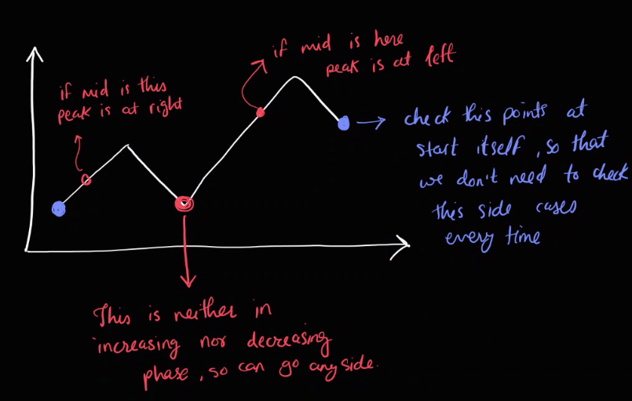
- Duplicates: Problem states all elements are distinctly comparable, so not allowed.

class Solution:
def findPeakElement(self, nums: List[int]) -> int:
nums_l = len(nums)
if nums_l==1 or nums[0]>nums[1]: #eliminate edge cases
return 0
if nums[-1]>nums[-2]:
return nums_l-1

l,r = 1,nums_l-2 #since edge cases are checked, shrink the sample spacce

while l<=r:
mid = (l+r)//2
if nums[mid-1]<nums[mid]>nums[mid+1]:
return mid
elif nums[mid]>nums[mid-1]: #increasing phase
l=mid+1
else:
r=mid-1

return -1 #code will never come here

Explanation:
- Edge cases first: If array has 1 element, or the first/last element beats its only neighbor, return that index immediately — this guarantees any peak found later has real neighbors on both sides.
- Shrink search space: Set l=1, r=n-2, since boundaries are already handled.
- Check mid as peak: At each step, if nums[mid] is bigger than both neighbors, it's a peak — return mid.
- Follow the slope: If nums[mid] > nums[mid-1] (going uphill), a peak must exist to the right, so search right half; otherwise (going downhill), a peak must exist to the left, so search left half.
- Why binary search works: The array can't keep increasing forever without hitting a peak (or an already-handled edge), so slope direction always tells you which half is guaranteed to contain a peak — letting you discard half the array each iteration, just like normal binary search, even though the array isn't sorted.

Easier code:

class Solution:
def findPeakElement(self, nums: List[int]) -> int:
left, right = 0, len(nums) - 1

# Binary search approach
while left < right: # When r not changing to mid+1, that time l<r, else l<=r
mid = (left + right) // 2

# If mid is greater than next, peak is on the left side (including mid)
if nums[mid] > nums[mid + 1]:
right = mid
else:
# Otherwise peak must be on the right side
left = mid + 1

# left == right → peak index
return left

Intuition: No need to handle edges separately here — imagine two virtual -infinity walls just outside both ends of the array. That guarantees a peak always exists somewhere inside, since the array can't fall off either edge without turning around first (or already being a peak at the edge).
- Compare nums[mid] with its right neighbor nums[mid+1].
- If nums[mid] > nums[mid+1], the array is descending at this point — a peak must exist at mid or somewhere to its left (since going left, values only rise or a peak sits right there), so keep mid in range: right = mid.
- Otherwise (nums[mid] <= nums[mid+1]), the array is still climbing — a peak must exist strictly to the right, so discard mid: left = mid + 1.
This always shrinks the search space by half based on slope direction, and since we never fully exclude the possible answer (right = mid, not mid - 1), the loop uses left < right (not <=) — when they finally meet, that index is guaranteed to be a peak.

LEVEL 2:

2. Search in 2D matrix

class Solution:
def searchMatrix(self, matrix: List[List[int]], target: int) -> bool:
n = len(matrix)
m = len(matrix[0])

l, r = 0, m-1

while r>=0 and l<n:
if matrix[l][r]==target:
return True
if matrix[l][r]>target:
r-=1
else:
l+=1

return False

Explanation
- Start search at top-right element (matrix[0][m-1]).
- From this position, you can move left (smaller numbers) or down (larger numbers).
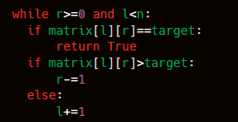
- If current element is too big, move left.
- If current element is too small, move down.
- This works because rows & columns are sorted.
If we exit the loop, it means we scanned all possible candidates → target not found.

3. Allocate Minimum Pages

class Solution:
def check(self,arr,mid,k):
student_cnt = 1
max_p = 0 #pages assigned to current student

for page in arr:
if max_p + page <= mid:
max_p += page
else:
student_cnt += 1
max_p = page

return student_cnt <= k

def findPages(self, arr, k):
n = len(arr)
# if number of books < number of students: return -1
if n<k:
return -1

l = max(arr)
r = sum(arr)

ans=-1

while l <= r:
mid = (l+r)//2
if self.check(arr,mid,k):
ans = mid #update answer to mid
r = mid - 1 #try for smaller value
else:
l = mid + 1 #try for larger value

return ans

- We have n books in an array arr[], where arr[i] = pages in book i.
- We must allocate books in order to k students.
- Each student gets contiguous books.
- Goal: minimize the maximum pages assigned to any student.

Approach:
Note: given arr is not required to be sorted:
The approach uses binary search on the answer: we guess the maximum pages (mid) a student can get, then check feasibility by allocating books sequentially. If feasible, try smaller; else increase. This minimizes the maximum pages per student.

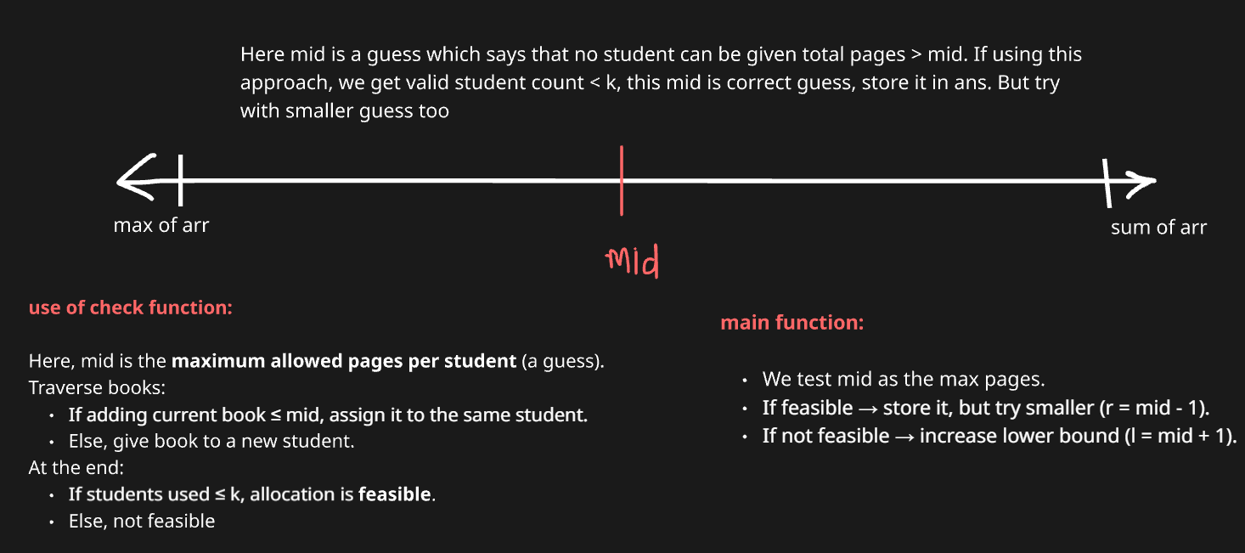

4. Koko Eating Bananas
class Solution:
def check(self, arr: List[int], mid: int, h: int) -> bool:
total_hr = 0
for pile in arr:
total_hr += ceil(pile / mid) # add hours, not overwrite
if total_hr > h:
return False
return True

def minEatingSpeed(self, piles: List[int], h: int) -> int:
l, r = 1, max(piles) # search space is 1…max pile
ans = r

while l <= r:
mid = (l + r) // 2
if self.check(piles, mid, h):
ans = mid
r = mid - 1
else:
l = mid + 1
return ans

Approach:
We apply binary search on the answer space from 1 to max(piles).
At each mid-speed, we check if Koko finishes within h hours.
If yes, shrink search to find smaller valid speed; else, increase speed.
This guarantees the smallest feasible speed.

Dry run example:
piles = [3,6,7,11], h = 8
- Search space: 1 … 11
- mid = 6 → hours = ceil(3/6)+ceil(6/6)+ceil(7/6)+ceil(11/6) = 1+1+2+2 = 6 ≤ 8 ✅ (valid, try smaller)
- mid = 3 → hours = 1+2+3+4 = 10 > 8 ❌ (too slow)
- mid = 4 → hours = 1+2+2+3 = 8 ≤ 8 ✅ (valid, try smaller)
- mid = 5 → hours = 1+2+2+3 = 8 ≤ 8 ✅
Answer = 4 (minimum valid speed).

5. Find the Smallest Divisor Given a Threshold

class Solution:

def isValid(self,nums,mid,threshold):
sum_v = 0
for num in nums:
sum_v += math.ceil(num/mid)
return sum_v <= threshold

def smallestDivisor(self, nums: List[int], threshold: int) -> int:
l = 1
r = max(nums)
ans = -1
while l<=r:
mid = (l+r)//2
if self.isValid(nums,mid,threshold):
ans = mid
r = mid - 1
else:
l = mid + 1
return ans

We apply binary search on divisor values from 1 to max(nums).
For each mid divisor, calculate sum of ceil(num/mid).
If sum ≤ threshold, divisor is valid → try smaller.
Else, divisor too small → increase it.

